Aim:

        To develop a Simple Android Application that draws basic Graphical Primitives on the screen.

Procedure:

Creating a New project:

* Open Android Studio and then click on **File -> New -> New project.**

[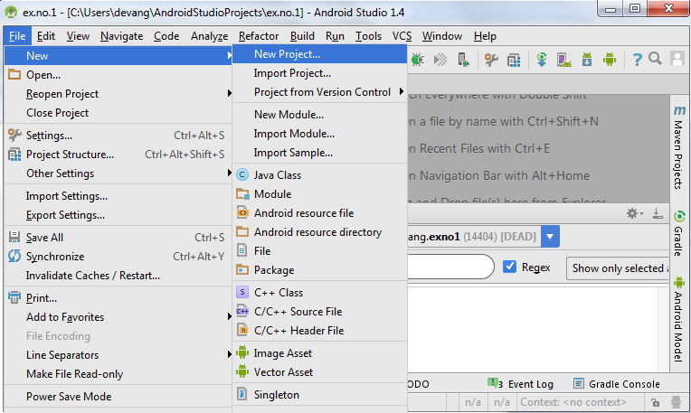](https://codingconnect.net/wp-content/uploads/2016/02/new-project.png)

* Then type the Application name as “**ex.no.4″** and click **Next.**

[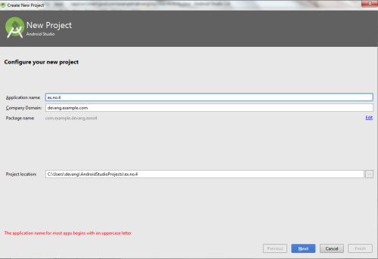](https://codingconnect.net/wp-content/uploads/2016/03/application-name-4-e1457453961332.png)

* Then select the **Minimum SDK** as shown below and click **Next**.

[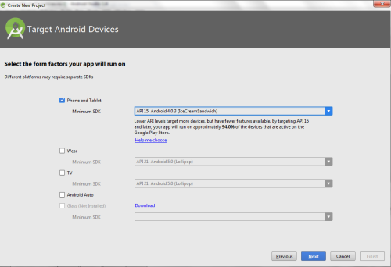](https://codingconnect.net/wp-content/uploads/2016/02/minimum-sdk-e1456069978476.png)

* Then select the **Empty Activity**and click **Next.**

[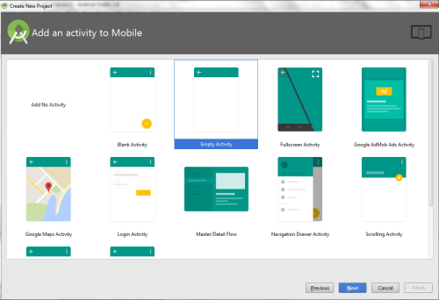](https://codingconnect.net/wp-content/uploads/2016/02/empty-activity-e1456120797105.png)

* Finally click F**inish**.

[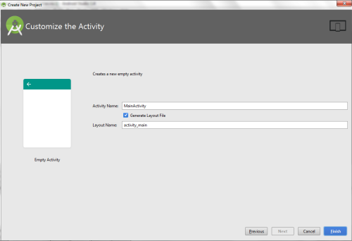](https://codingconnect.net/wp-content/uploads/2016/02/finish-e1456121463611.png)

* It will take some time to build and load the project.
* After completion it will look as given below.

[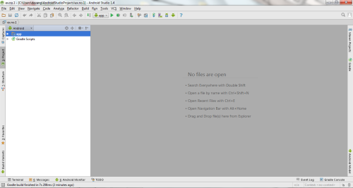](https://codingconnect.net/wp-content/uploads/2016/02/new-e1456122290334.png)

Designing layout for the Android Application:

* Click on **app -> res -> layout -> activity_main.xml.**

[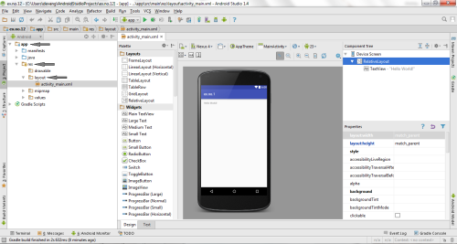](https://codingconnect.net/wp-content/uploads/2016/02/activity_main-e1456123429693.png)

* Now click on **Text** as shown below.

[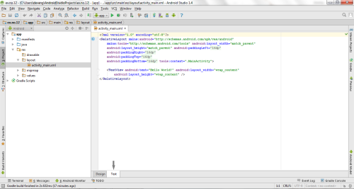](https://codingconnect.net/wp-content/uploads/2016/02/text-e1456124006902.png)

* Then delete the code which is there and type the code as given below.

**Code for Activity_main.xml:**

[?](https://www.codingconnect.net/android-application-basic-graphical-primitives/)

|  |  |
| --- | --- |
| 1  2  3  4  5  6  7  8  9  10 | <?**xml** version="1.0" encoding="utf-8"?>  <**RelativeLayout** xmlns:android="http://schemas.android.com/apk/res/android"      android:layout_width="match_parent"      android:layout_height="match_parent">        <**ImageView**          android:layout_width="match_parent"          android:layout_height="match_parent"          android:id="@+id/imageView" />  </**RelativeLayout**> |

* Now click on **Design** and your application will look as given below.

[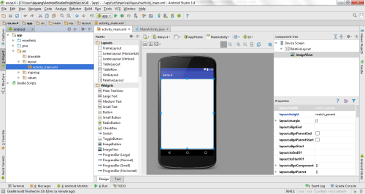](https://codingconnect.net/wp-content/uploads/2016/03/design-4-e1457454769185.png)

* So now the designing part is completed.

Java Coding for the Android Application:

* Click on **app -> java -> com.example.exno4 -> MainActivity.**

[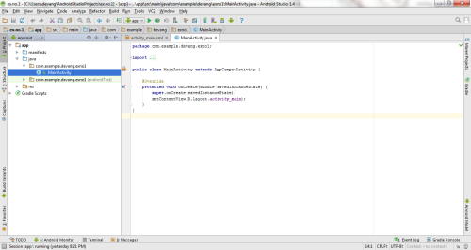](https://codingconnect.net/wp-content/uploads/2016/02/MainActivity-e1456597575355.png)

* Then delete the code which is there and type the code as given below.

**Code for MainActivity.java:**

[?](https://www.codingconnect.net/android-application-basic-graphical-primitives/)

|  |  |
| --- | --- |
| 1  2  3  4  5  6  7  8  9  10  11  12  13  14  15  16  17  18  19  20  21  22  23  24  25  26  27  28  29  30  31  32  33  34  35  36  37  38  39  40  41  42  43  44  45  46  47  48  49  50  51 | **package** com.example.exno4;    **import** android.app.Activity;  **import** android.graphics.Bitmap;  **import** android.graphics.Canvas;  **import** android.graphics.Color;  **import** android.graphics.Paint;  **import** android.graphics.drawable.BitmapDrawable;  **import** android.os.Bundle;  **import** android.widget.ImageView;    **public** **class** MainActivity **extends** Activity  {      @Override  **public** **void** onCreate(Bundle savedInstanceState)      {  **super**.onCreate(savedInstanceState);          setContentView(R.layout.activity_main);            //Creating a Bitmap          Bitmap bg = Bitmap.createBitmap(720, 1280, Bitmap.Config.ARGB_8888);            //Setting the Bitmap as background for the ImageView          ImageView i = (ImageView) findViewById(R.id.imageView);          i.setBackgroundDrawable(**new** BitmapDrawable(bg));            //Creating the Canvas Object          Canvas canvas = **new** Canvas(bg);            //Creating the Paint Object and set its color & TextSize          Paint paint = **new** Paint();          paint.setColor(Color.BLUE);          paint.setTextSize(50);            //To draw a Rectangle          canvas.drawText("Rectangle", 420, 150, paint);          canvas.drawRect(400, 200, 650, 700, paint);            //To draw a Circle          canvas.drawText("Circle", 120, 150, paint);          canvas.drawCircle(200, 350, 150, paint);            //To draw a Square          canvas.drawText("Square", 120, 800, paint);          canvas.drawRect(50, 850, 350, 1150, paint);            //To draw a Line          canvas.drawText("Line", 480, 800, paint);          canvas.drawLine(520, 850, 520, 1150, paint);      }  } |

* So now the Coding part is also completed.
* Now run the application to see the output.

Output:

[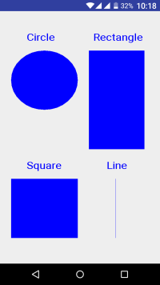](https://codingconnect.net/wp-content/uploads/2016/03/Screenshot_2016-03-08-22-18-18-e1457455792843.png)

Result:

              Thus a Simple Android Application that draws basic Graphical Primitives on the screen is developed and executed successfully.